**May 5 Home questions**

#1. WAP to test whether a number num (num is entered through keyboard)

is a number in the Fibonacci sequence or not.

Code:

#include <stdio.h>

int main()

{

    int fib_285[100],num_285,i_285,j_285,flag=0;

    printf("Please provide your number\n");

    scanf("%d",&num_285);

    fib_285[0]=0;

    fib_285[1]=1;

    fib_285[2]=fib_285[1]+fib_285[0];

    for(i_285=0;i_285<50;i_285++)

    {

        fib_285[i_285+2]=fib_285[i_285+1]+fib_285[i_285];

    }

    for(i_285=0;i_285<50;i_285++)

    {

        if(num_285==fib_285[i_285])

        {

            printf("Yes, %d is in the fibonacci series located on the %d term\n",num_285,i_285);

            flag++;

            break;

        }

    }

    if(flag==0)

    {

        printf("No, %d is not in the fibonacci series!\n",num_285,i_285);

    }

    return 0;

}

Output:

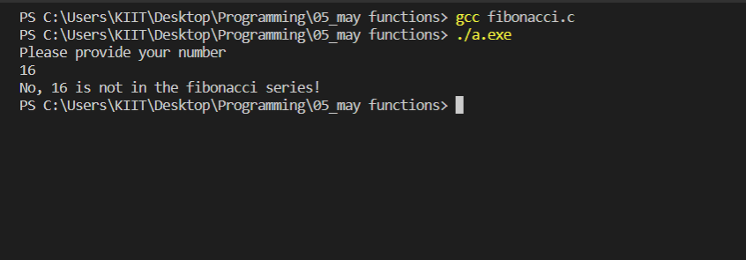

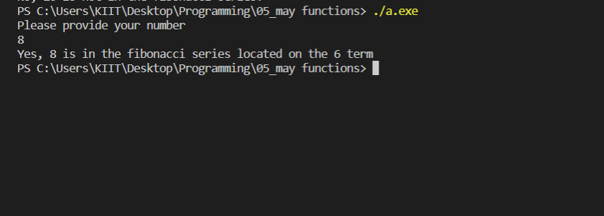

#2. WAP to compute the power series (e to the power x).

Code:

#include <stdio.h>

#include <math.h>

float fact(float f_285)

{

    float i_285,n_285;

    n_285=f_285;

    for(i_285=1;i_285<f_285;i_285++)

    {

        n_285=n_285*(f_285-i_285);

    }

    return n_285;

}

int main()

{

    float terms_285,x_285,i_285,qoutient_285,sum_285=0;

    printf("How many terms do you want to be added\n");

    scanf("%f",&terms_285);

    printf("What is our 'x'?\n");

    scanf("%f",&x_285);

    for(i_285=1;i_285<=terms_285;i_285++)

    {

        qoutient_285= pow(x_285,i_285)/fact(i_285);

        sum_285=sum_285+qoutient_285;

    }

    printf("%f is the value of e^%f\n",sum_285+1,x_285);

    return 0;

}

Output:

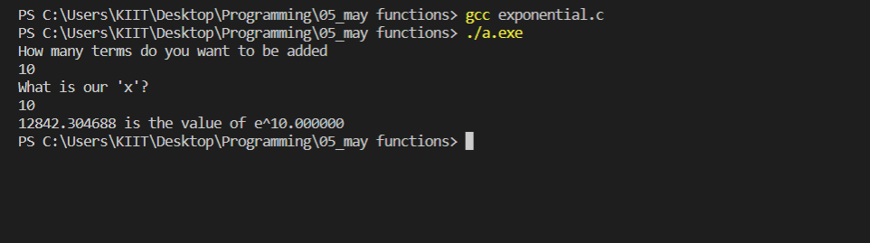

#3. WAP to find the LCM of two numbers a and b by using a suitable function (say LCM) for this.

Code:

#include <stdio.h>

void LCM(int a_285,int b_285)

{

    int i_285,result_285;

    for(i_285=1;i_285<5000;i_285++)

    {

        if(i_285%a_285==0 && i_285%b_285==0)

        {

            printf("LCM of %d and %d is %d\n",a_285,b_285,i_285);

            break;

        }

    }

}

int main()

{

    int a_285,b_285;

    printf("Please provide the two numbers\n");

    scanf("%d%d",&a_285,&b_285);

    LCM(a_285,b_285);

    return 0;

}

Output:

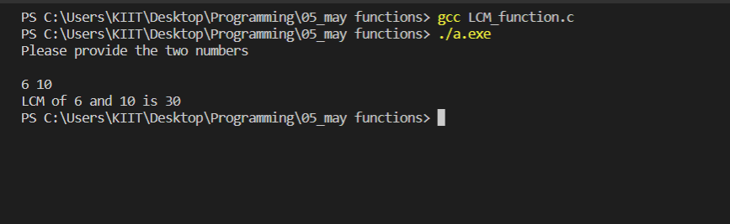

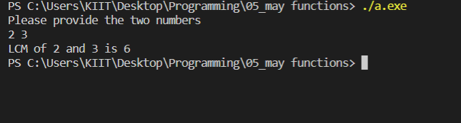

#4. A Fibonacci sequence is defined as follows: the first and second terms in

the sequence are 0 and 1. Subsequent terms are found by adding the preceding

two terms in the sequence (Fi = Fi−1 + Fi−2).

Code:

#include <stdio.h>

int main()

{

    int fib_285[100],num_285,i_285,j_285;

    printf("How many fibonacci terms do you want to be printed out?\n");

    scanf("%d",&num_285);

    fib_285[0]=0;

    fib_285[1]=1;

    fib_285[2]=fib_285[1]+fib_285[0];

    for(i_285=0;i_285<num_285;i_285++)

    {

        fib_285[i_285+2]=fib_285[i_285+1]+fib_285[i_285];

    }

    printf("Your fibonacci series is as follows\n");

    for(i_285=0;i_285<num_285;i_285++)

    {

        printf("%d ",fib_285[i_285]);

    }

    return 0;

}

Output:

